Hadoop Developer – Sqoop Lab Exercises
Hadoop Developer Training-
Sqoop Lab Book

Table of Contents

- Creating a table in RDBMS ……………………………………………… 3

- Importing RDBMS data into HDFS……………………………………… 3

- Exporting HDFS data to RDBMS……………………………………….. 6

Creating Table in RDBMS:

- Open My Sql Instance either in My sql editor or command line.
- Mysql – u root –p
- Select database();
- Show tables;
- Use test;
- Show databases;

- Create a table named customer using below query in test database:
CREATE TABLE test.customer (cust_id int, name varchar(50), age int, country varchar(100));
- Insert data into table customer
INSERT INTO test.customer VALUES(101,'John',25,'US');
INSERT INTO test.customer VALUES(102,'Jack',35,'US');
INSERT INTO test.customer VALUES(103,'Peter',28,'UK');
INSERT INTO test.customer VALUES(104,'Katie',30,'US');
INSERT INTO test.customer VALUES(105,'Daniel',22,'UK');
- Check whether data is inserted in customer table or not
SELECT * FROM test.customer;
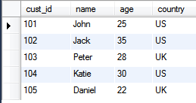

Importing RDBMS data into HDFS:

- Check whether mysql-connectorXXXX.jar is present or not under /usr/lib/sqoop directory of your hadoop machine.

- If not, then download and copy the mysql-connector jar to /usr/lib/sqoop directory.

- Import customer table’s data to HDFS using sqoop command.
$ sqoop-import --connect jdbc:mysql://192.168.117.131/test \
--username root –password root \
--table customer \
--target-dir /etl/input/
Note : Instead of sandbox IP Use localhost and without password parameter
sqoop import --connect jdbc:mysql://localhost/test --username root --table customer --target-dir /user/root/customer --m 1

sqoop import --connect jdbc:mysql://localhost/test --username root --table customer --where “country = ‘US’”--target-dir /user/root/customer --m 1

[root@sandbox ~]# hadoop fs -ls /user/root/customer
Found 2 items
-rw-r--r-- 1 root hdfs 0 2016-11-21 07:19 /user/root/customer/_SUCCESS
-rw-r--r-- 1 root hdfs 31 2016-11-21 07:19 /user/root/customer/part-m-00000
[root@sandbox ~]# hadoop fs -cat /user/root/customer/part-m-00000
102,Jack,40,US
104,Katie,30,US
Note: Please delete the customer directory from HDFS(if present) before running sqoop command.

- Check whether data is imported to HDFS or not from customer table
$ hadoop fs -cat /etl/input/customer/part-m*

- Import only those records of customer table where country is ‘US’
mysql> desc customer
-> ;
+---------+--------------+------+-----+---------+-------+
| Field | Type | Null | Key | Default | Extra |
+---------+--------------+------+-----+---------+-------+
| cust_id | int(11) | YES | | NULL | |
| name | varchar(50) | YES | | NULL | |
| age | int(11) | YES | | NULL | |
| country | varchar(100) | YES | | NULL | |
+---------+--------------+------+-----+---------+-------+
4 rows in set (0.00 sec)

mysql> select * from customer;
+---------+--------+------+---------+
| cust_id | name | age | country |
+---------+--------+------+---------+
| 102 | Jack | 40 | US |
| 103 | Peter | 28 | UK |
| 104 | Katie | 30 | US |
| 105 | Daniel | 22 | UK |
+---------+--------+------+---------+
4 rows in set (0.02 sec)

$ sqoop-import --connect jdbc:mysql://192.168.1.121/test \
--username root –password root \
--table customer \
--where “country = ‘US’” \
--target-dir /etl/input/US/
$ sqoop-import --connect jdbc:mysql://192.168.1.121/test \
--username root –password root \
--table customer \
--query ‘SELECT id,name,age FROM test.customer WHERE $CONDITION ‘
-- where “country=’UK’” \
--split-by id \
--target-dir /etl/input/UK/
Note :
sqoop import --connect jdbc:mysql://localhost/test --username root --query ‘SELECT cust_id,name,age FROM test.customer WHERE $CONDITIONS and country = “UK”’ --target-dir /user/root/ukquery --m 1

sqoop import --connect jdbc:mysql://localhost/test --username root --query 'SELECT cust_id,name,age FROM test.customer WHERE $CONDITIONS and country = "UK"' --target-dir /user/root/ukquery --m 1

- Import only id, name and age from customer table belonging to UK and load to /etl/input/selected/customer path in HDFS

$ sqoop-import --connect jdbc:mysql://192.168.1.121/test \
--username root –password root \
--table customer \
--query ‘SELECT id,name,age FROM test.customer WHERE $CONDITIONS and country=”UK’’’ \
--split-by id \
--target-dir /etl/input/UK/
Note: --split-by is used for slicing data to multiple parallel tasks. Usually done on primary key of table.

- Defining number of mappers explicitly
$ sqoop-import --connect jdbc:mysql://192.168.1.121/test \
--username root –password root \
--table customer \
--target-dir /etl/input/ \
-m 5
- Import customer table data to HDFS as avro data file
$ sqoop-import --connect jdbc:mysql://192.168.1.121/test \
--username root –password root \
--table customer \
--target-dir /etl/input/
--as-avrodatafile
- Import the data of customer table to hive table
$ sqoop-import --connect jdbc:mysql://192.168.1.121/test \
--username root –password root \
--table customer \
--hive-import

sqoop import --connect jdbc:mysql://localhost/test --username root --table customer --hive-table customer3 --hive-import --m 1
- Check whether data is loaded to Hive table correctly
Select * from customer;
- Add 1 row to your customer table in mysql
INSERT INTO test.customer VALUES(106,'Vipul',25,'IN');
- Check whether data is inserted in customer table or not
SELECT * FROM test.customer

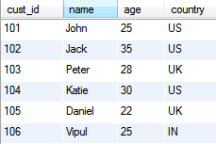

- Append the newly added row(incremental import) in customer table to /etl/input/ directory of HDFS
$ sqoop-import --connect jdbc:mysql://192.168.1.121/test \
--username root –password root \
--table customer \
--incremental append \
--check-column id \
--last-value 105 \
--target-dir /etl/input/
- Import the data of customer table to Hbase

$ sqoop-import --connect jdbc:mysql://192.168.1.121/test \
-Dsqoop.hbase.add.row.key=true \
--username root –password root \
--table customer \
--hbase-table customer \
--column-family market
Note: HBase table and column family should exist before importing using sqoop.

Exporting HDFS data into RDBMS:
- Create a new table in mysql with name customer_new in test db in which we will export data from HDFS
CREATE TABLE test.customer_new (cust_id int, name varchar(50), age int, country varchar(100));

- Check whether data is present in HDFS path /etl/input/customer/ or not
$ hadoop fs -cat /etl/input/customer/part*

- Export data from HDFS path /etl/input/customer/ to customer_new table in RDBMS under test db
$ sqoop-export --connect jdbc:mysql://192.168.1.121/test
--username root --password root \
--table customer_new \
--export-dir /etl/input/customer/part* -m 2
sqoop-export --connect jdbc:mysql://localhost/test --username root --table customer_new --export-dir /user/root/customer/part* -m 2

- Check whether data is exported to customer_new table of mysql or not
SELECT * FROM customer_new;

- Export the data from HDFS to mysql table customer_new: Update existing records and add newly added records.
$ sqoop-export --connect jdbc:mysql://192.168.1.121/test
--username root --password root \
--table customer_new \
--update-key id \
--update-mode allowinsert --export-dir /etl/input/customer/part*


About Capgemini
With almost 145,000 people in over 40 countries, Capgemini is one of the world's foremost providers of consulting, technology and outsourcing services. The Group reported 2014 global revenues of EUR 10.573 billion.
Together with its clients, Capgemini creates and delivers business and technology solutions that fit their needs and drive the results they want. A deeply multicultural organization, Capgemini has developed its own way of working, the Collaborative Business Experience™, and draws on Rightshore®, its worldwide delivery model

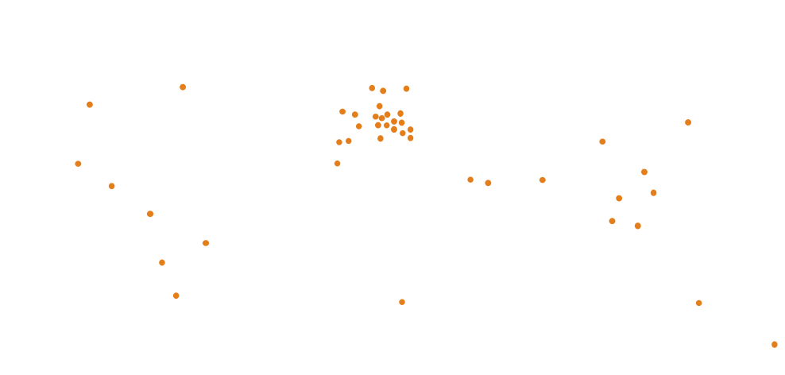 | Name Name  Function  Function  Phone:00 00 00 00 00  email@capgemini.com
Name Name
Function
Function
Phone:00 00 00 00 00
email@capgemini.com
Name Name
Function
Function
Phone:00 00 00 00 00
email@capgemini.com
Name Name
Function
Function
Phone:00 00 00 00 00
email@capgemini.com
www.capgemini.com

The information contained in this document is proprietary and confidential.
It is for Capgemini internal use only. Copyright © 2015 Capgemini. All rights reserved.
Rightshore® is a trademark belonging to Capgemini.

